**REPORT ON EYE FOR TOMORROW'S CHILDREN**

**NAME:** *AMAM BOL NUER*

**NATIONATY***: SUOTH SUNDANE*

**EMAIL***: juneammamy@gmail.com*

**PHONE NO:** *0114319010*

**COURSE***: DATA ANALYSTICS*

**NAME OF PROJECT***: EYE FOR TOMORROW’S CHIRDREN*

**1. Demographics**

* **Location:**
  + Majority reside in Kakuma 1 (63.6%), followed by Kakuma 2 (20.9%) and Kakuma 3 (11.6%).
  + Kalobeyei and Kakuma Town combined account for only 4%
* **Age:**
  + Mean: **24.04 years**, with most respondents aged between 21 (25th percentile) and 26 years (75th percentile).

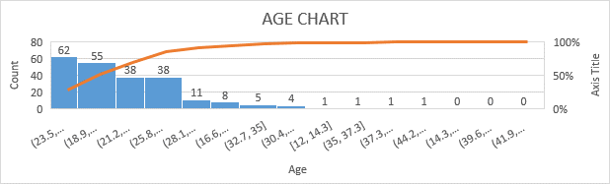

* **Nationality:**
  + Predominantly South Sudanese (**79.1%**), followed by Sudanese (**11.1%**) and Somali (**3.1%**).
* **Education:**
  + **88.4%** of respondents have completed high school. Only **8.4%** possess university-level education, and **3.1%** have no formal education.

**2. Awareness and Understanding of Child Welfare Initiatives**

* **Child Protection:**
  + Universal agreement (**100%**) that child protection is about safety and rights.
* **"Eye for Tomorrow’s Children" Awareness:**
  + **53.3%** have not heard about it, while **46.7%** are aware.
* **Primary Goal:**
  + **100%** agree the initiative aims to ensure children’s rights and well-being.

**3. Child Welfare Programs**

* **Targeted Age Groups:**
  + Majority (**69.3%**) believe all children (ages 6-18) are targeted, while **27.1%** focus on ages 13-18.
* **Community Role:**
  + Universal consensus (**100%**) on the importance of educating members about child abuse signs.
* **Educators’ Role:**
  + **100%** agree educators should monitor children’s development and provide support.

**4. Health and Emotional Well-being**

* **Vision Problems:**
  + Commonly recognized signs include low energy (**73.3%**) and frequent headaches (**16%**).
* **Mental Health Promotion:**
  + **96.9%** emphasize open communication, while **3.1%** incorrectly associate it with isolation.
* **Emotional Well-being:**
  + Majority (**52.9%**) associate it with good communication. Quiet behaviors (**32%**) and shyness (**12.9%**) are less accurate indicators.

**5. Security and Welfare**

* **Child Security:**
  + **100%** agree children feel secure in a supportive environment.
* **Beneficiaries of Child Welfare Services:**
  + Predominantly children in need (**98.7%**).
* **Who Supports Welfare:**
  + Teachers and parents are the key supporters (**98.2%**).

**Key Observations**

* High awareness of core concepts like child protection and welfare roles.
* Opportunities to increase awareness about specific initiatives like "Eye for Tomorrow’s Children."
* Data quality issues in numerical entries (e.g., phone numbers) warrant further cleaning.